**Experiment 1**

**Aim:** Write a program to construct a social network object using Sociomatrix.

**Flowchart:**

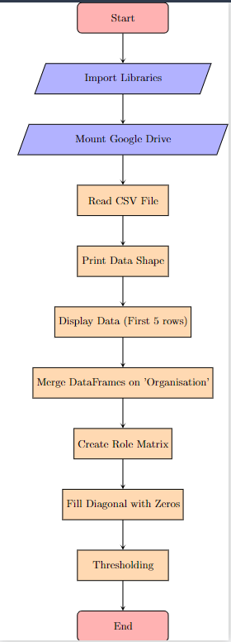

**Code:**

#Sociomatrix- It is a square matrix where rows and columns represent the nodes (individuals or entities) in the network

#and the entries in the matrix represent the presence or absence of relationships between nodes.

#social network object

#a "social network object" refers to a data structure that represents a social network or a network of relationships between individuals or entities

import pandas as pd #Pandas is a Python library used for working with data sets. #It has functions for analyzing, cleaning, exploring, and manipulating data.

import numpy as np # NumPy is used for working with arrays.

import networkx as nx #for working with graphs and networks

import matplotlib.pyplot as plt #for plotting graphs

%matplotlib inline

from operator import itemgetter #If multiple items are specified, returns a tuple of lookup values. eg: itemgetter(1, 3, 5)('ABCDEFG') ->output:('B', 'D', 'F')

from google.colab import drive

drive.mount('/content/drive/')

df = pd.read_csv ("/content/drive/MyDrive/organization.csv")

print(df.shape)

df.head(5)

df_merge = df.merge(df,on="Organisation")

role_mat = pd.crosstab(df_merge.member_x,df_merge.member_y) #This function allows you to compute a frequency table of two or more variables # get counts of categories

np.fill_diagonal(role_mat.values, 0) # Return the filled value in the diagonal of an array.

role_mat[role_mat >= 1] = 1

role_mat

**Output:**

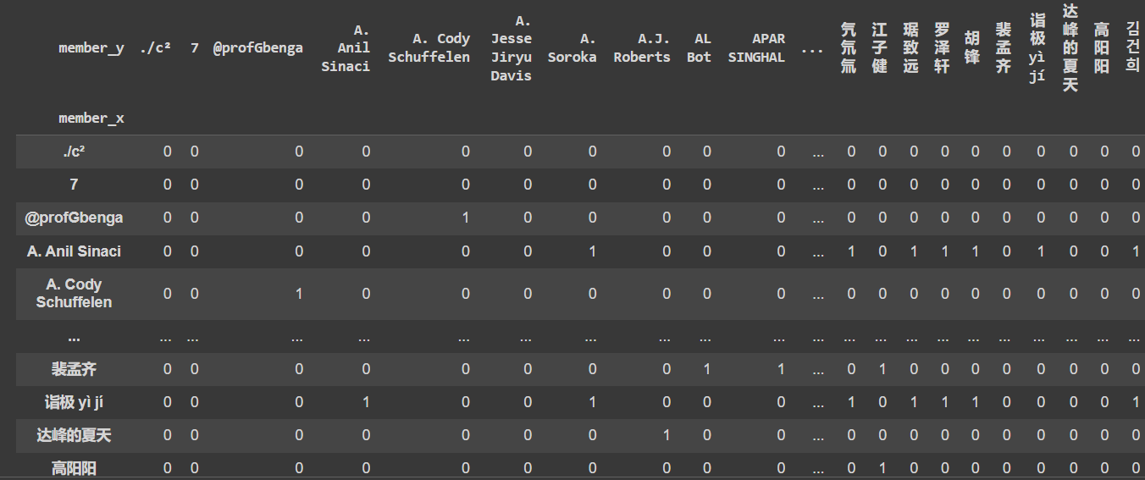

**Experiment 2**

**Aim:** Write a program to create node and edge lists network objects.

**Flowchart:**

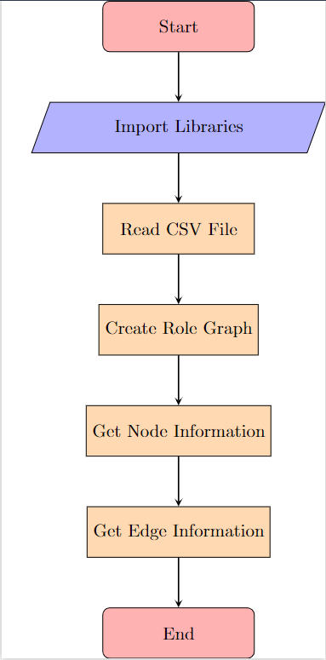

**Code:**

import pandas as pd

import numpy as np

import networkx as nx #NetworkX provides classes for graphs which allow multiple edges between any pair of nodes.

#for the creation, manipulation, and study of the structure, dynamics, and functions of complex networks.

import matplotlib.pyplot as plt

%matplotlib inline

from operator import itemgetter #If multiple items are specified, returns a tuple of lookup values. eg: itemgetter(1, 3, 5)('ABCDEFG') ->output:('B', 'D', 'F')

df = pd.read_csv ("/content/drive/MyDrive/organization.csv")

#Returns a graph from Pandas DataFrame containing an edge list

role_graph= nx.from_pandas_edgelist(df,source="member",target="Organisation")

type(role_graph)

role_graph.nodes()

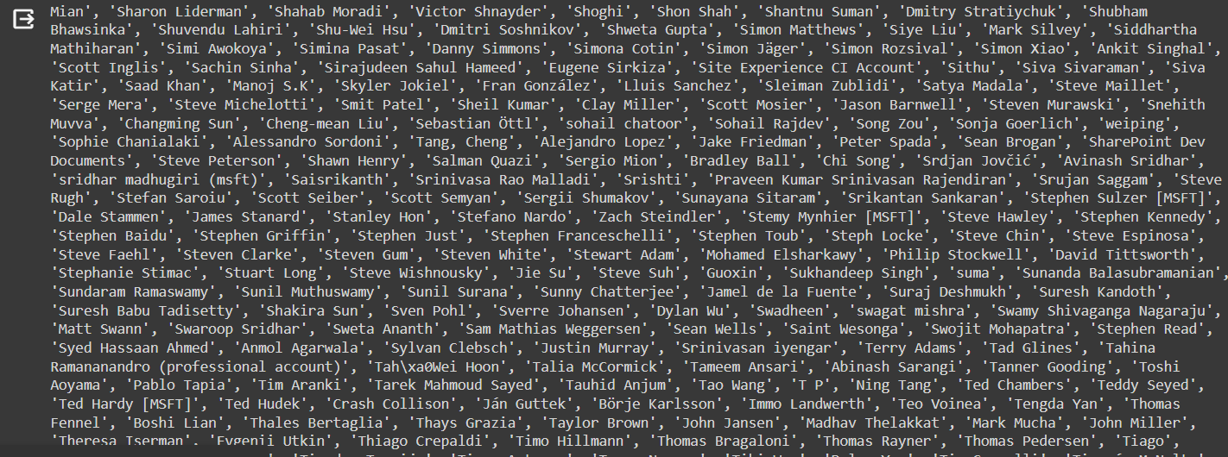

len(role_graph.nodes())



role_graph.edges()

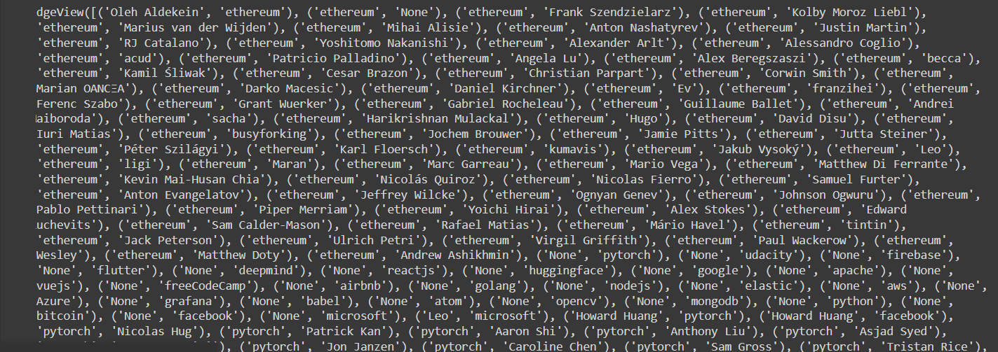

len(role_graph.edges())



**Experiment 3**

**Aim:** Write a program to visualize a social network with matplotlib library.

**Flowchart:**

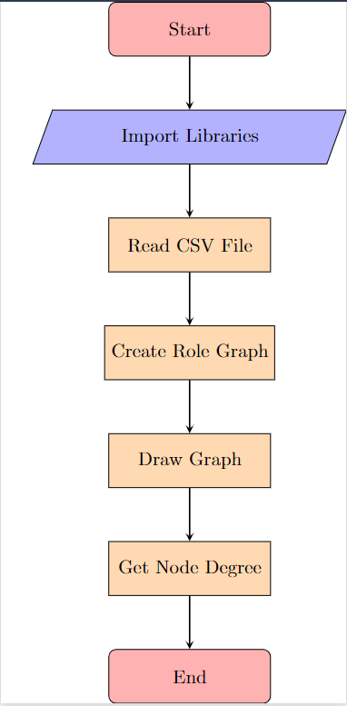

**Code:**

df = pd.read_csv("/content/drive/MyDrive/organization.csv")

nx.draw(role_graph)

#Draw the graph as a simple representation with no node labels or edge labels and using the full Matplotlib figure area and no axis labels by default

nx.degree(role_graph) #The node degree is the number of edges adjacent to the node

**Output:**

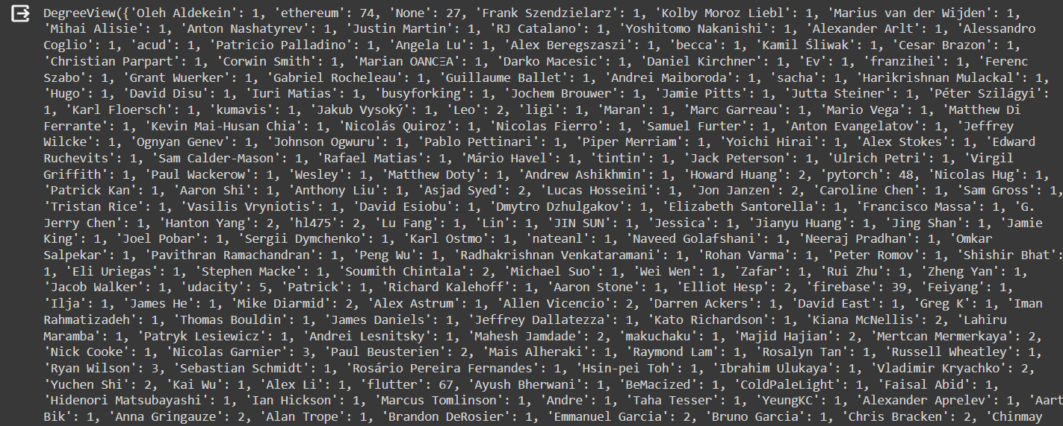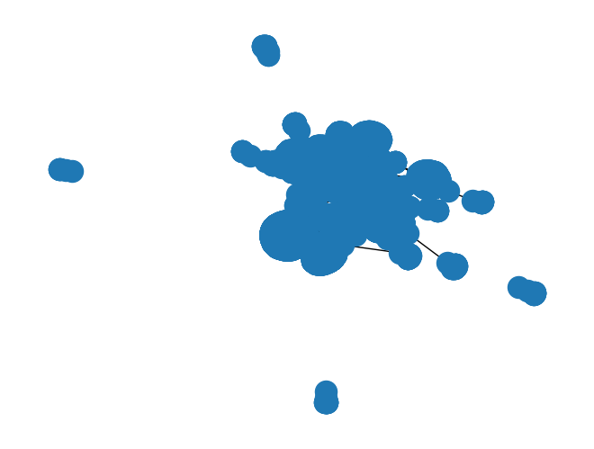

**Experiment 4**

**Aim:** Write a program to calculate the node-level degree centrality measures for social network and plot the graph.

**Flowchart:**

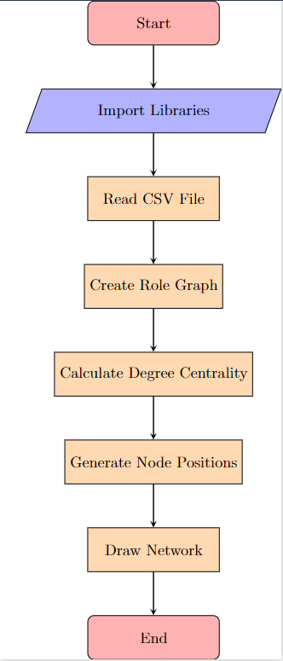

**Code:**

import pandas as pd

import numpy as np

import networkx as nx

import matplotlib.pyplot as plt

%matplotlib inline

from operator import itemgetter #suite of standard Python operators

df=pd.read_csv("/content/drive/MyDrive/organization.csv")

nx.degree_centrality(role_graph) #The degree centrality for a node v is the fraction of nodes it is connected to.

#G = nx.Graph([(0, 1), (0, 2), (0, 3), (1, 2), (1, 3)])

#nx.degree_centrality(G)

#{0: 1.0, 1: 1.0, 2: 0.6666666666666666, 3: 0.6666666666666666} 0 is connected with all 3 nodes so its degree centrality is 1 while 2 is connected with 2 out of 3 so 66%

pos = nx.spring_layout(role_graph) #Position nodes using Fruchterman-Reingold force-directed algorithm.

#The algorithm simulates a force-directed representation of the network treating edges as springs holding nodes close

#while treating nodes as repelling objects, sometimes called an anti-gravity force. Simulation continues until the positions are close to an equilibrium.

degCent = nx.degree_centrality(role_graph)

node_color = [20000.0 * role_graph.degree(v) for v in role_graph]

node_size = [v * 10000 for v in degCent.values()]

plt.figure(figsize=(15,15))

nx.draw_networkx(role_graph, with_labels=False,

node_color=node_color,

node_size=node_size )

plt.axis('off')

sorted(degCent, key=degCent.get, reverse=True)[:5]

**Output:**

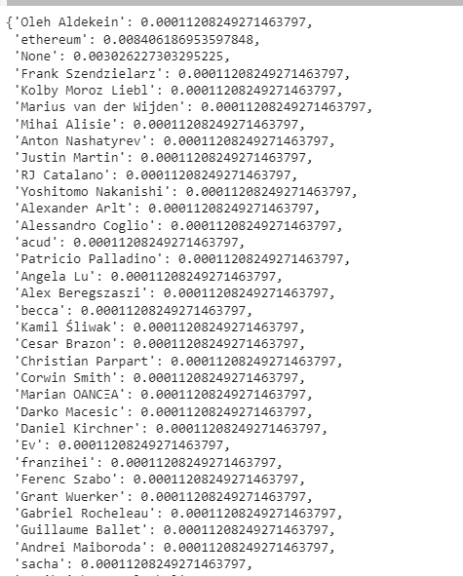

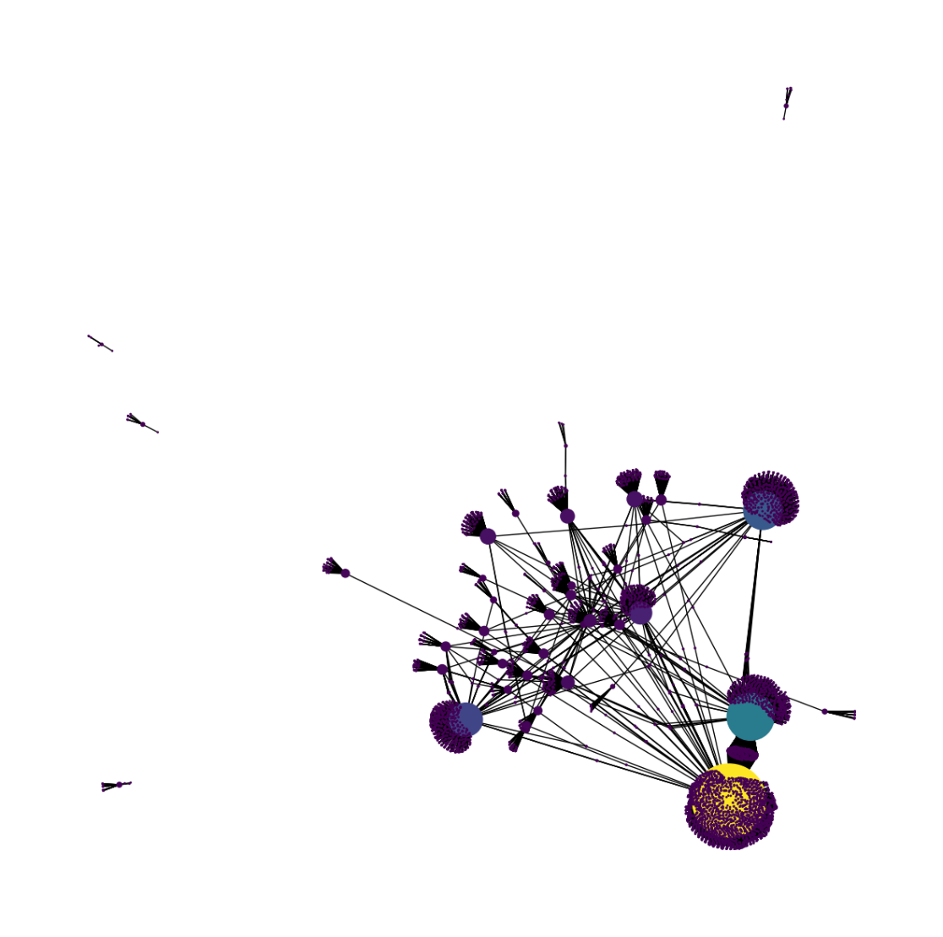

**Experiment 5**

**Aim:** Write a program to calculate the node-level betweenness centrality and closeness centrality measures for social network and plot the graph.

**Flowchart:**

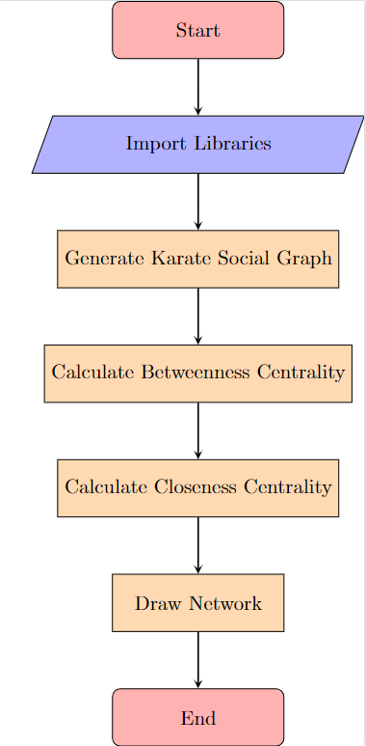

**Code:**

import random

import networkx as nx

# G is the Karate Social Graph

G = nx.karate_club_graph()

# betweenness_centrality

b=nx.betweenness_centrality(G)

print(b)

# closeness_centrality

c = nx.closeness_centrality(G)

print(c)

plt.figure(figsize =(15, 15))

nx.draw_networkx(G, with_labels = True)

**Output:**



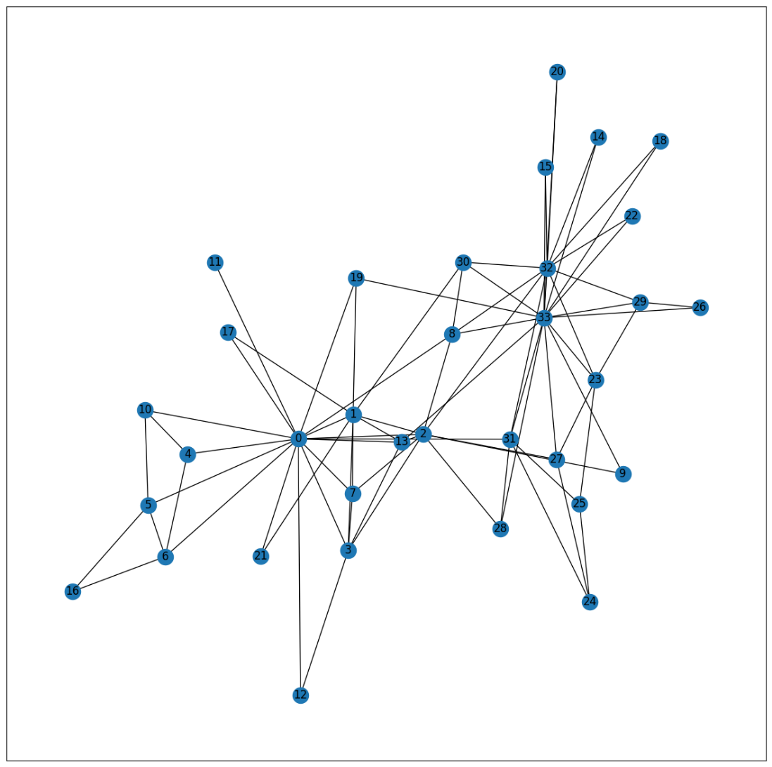

**Experiment 6**

**Aim:** Write a program to create network-level measures of centrality for social network.

**Flowchart:**

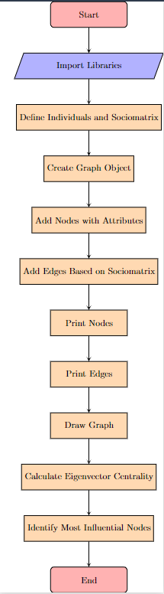

**Code:**

import numpy as np

import networkx as nx

import matplotlib.pyplot as plt

# Define the names of individuals

names = ['Node_A', 'Node_B', 'Node_C']

# Define the sociomatrix

sociomatrix = np.array([

# A , B , C

[0, 1, 0 ], # Node_A

[1, 0, 1 ], # Node_B

[0, 1, 0 ] # Node_C

])

# Creating a Graph Object

G = nx.Graph()

# Adding Nodes with Attributes

for i, name in enumerate(names):

G.add_node(name)

# Adding Edges Based on Sociomatrix

for i in range(len(names)):

for j in range(i + 1, len(names)):

if sociomatrix[i][j] == 1:

G.add_edge(names[i], names[j])

# Print the nodes of the graph

print("Nodes of the social network:")

print(names)

# Print the edges of the graph

print("Edges of the social network:")

print(list(G.edges()))

# Drawing the Graph

pos = nx.spring_layout(G) # Positions for all nodes

plt.figure(figsize=(6,6))

nx.draw(G, pos, with_labels=True, node_size=500, node_color='skyblue',

font_size=10, font_weight='bold', edge_color='gray')

# Displaying the Graph

plt.title('Social Network Visualization')

plt.show()

eigenvector_centrality = nx.eigenvector_centrality(G)

#Sort for identifying most inflential nodes using eigenvector centrality

for node in sorted(eigenvector_centrality, key=eigenvector_centrality.get, reverse=True):

print(node, eigenvector_centrality[node])

**Output:**

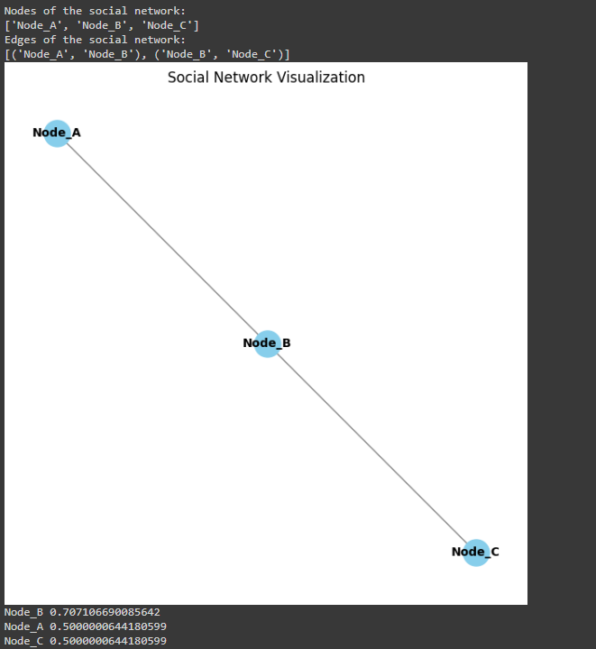

**Experiment 7**

**Aim:** Write a program to incorporate and plot network connectivity in a spatial regression model.

**Flowchart:**

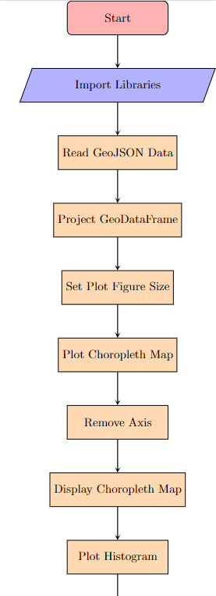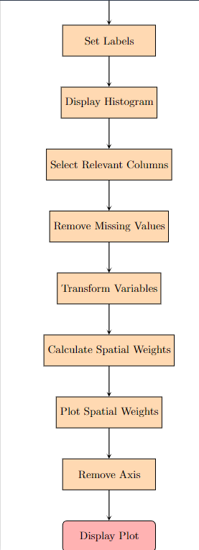

**Code:**

# Importing necessary libraries

import geopandas

import matplotlib.pyplot as plt

import numpy

import pysal.lib

# Reading GeoJSON data containing world energy indicators into a GeoDataFrame

countries = geopandas.read_file("https://michaelminn.net/tutorials/data/2019-world-energy-indicators.geojson")

# Projecting the GeoDataFrame to Web Mercator (EPSG:3857) projection

countries = countries.to_crs("EPSG:3857")

# Setting the size of the plot figure

plt.rcParams['figure.figsize'] = [9, 6]

# Plotting the choropleth map of MM_BTU_per_Capita using GeoDataFrame plot function

axis = countries.plot("MM_BTU_per_Capita", cmap="coolwarm", legend=True, scheme="quantiles")

# Removing axis

axis.set_axis_off()

# Displaying the plot

plt.show()

# Plotting a histogram of MM_BTU_per_Capita

axis = plt.hist(countries["MM_BTU_per_Capita"])

# Setting labels for x-axis and y-axis

plt.xlabel("MM BTU per Capita")

plt.ylabel("Number of Countries")

# Displaying the histogram plot

plt.show()

# Defining variables for modeling

dependent_name = ["Democracy_Index"]

independent_names = ["GDP_per_Capita_PPP_Dollars", "Military_Percent_GDP", "Resource_Rent_Percent_GDP", "Industry_Percent_GDP"]

# Selecting relevant columns from GeoDataFrame and removing rows with missing values

model_data = countries[dependent_name + independent_names + ["geometry", "Latitude", "Longitude"]]

model_data = model_data.dropna()

# Transforming certain variables by taking their natural logarithm plus one

transform_vars = ["GDP_per_Capita_PPP_Dollars", "Military_Percent_GDP", "Resource_Rent_Percent_GDP"]

model_data[transform_vars] = numpy.log(model_data[transform_vars] + 1)

# Calculating spatial weights using K-nearest neighbors (KNN) method

weights = pysal.lib.weights.KNN.from_dataframe(model_data, k=4)

# Plotting spatial weights on a map

axis = model_data.plot(edgecolor="lightgray", facecolor="none")

model_data["index"] = model_data.index

weights.plot(gdf=model_data, indexed_on="index", ax=axis)

# Removing axis

axis.set_axis_off()

# Displaying the plot

plt.show()

**Output:**

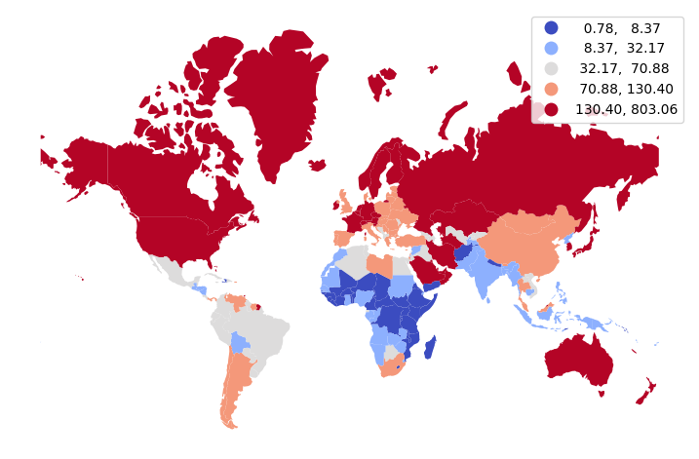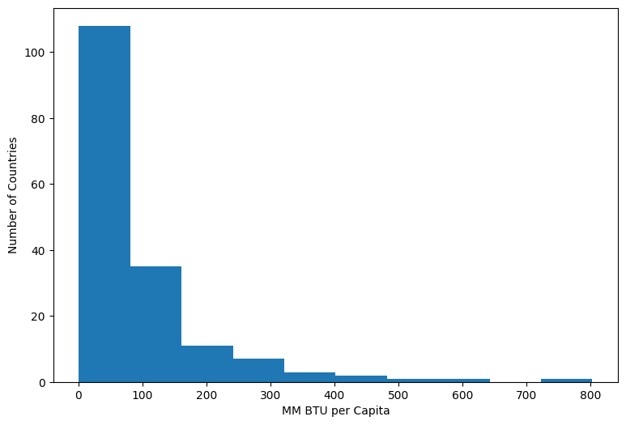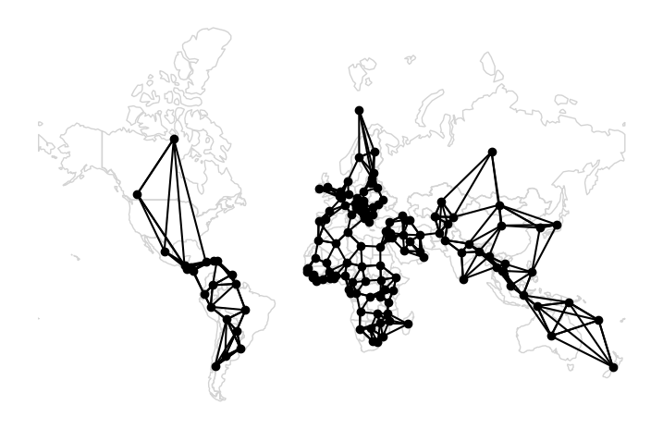

**Experiment 8**

**Aim:** Write a program for preprocessing of social media text and detect sentiment from it.

**Flowchart:**

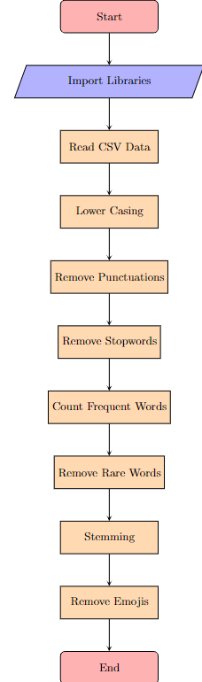

**Code:**

#TEXT PREPROCESSING

import numpy as np

import pandas as pd

import re

import nltk

import spacy

import string

pd.options.mode.chained_assignment = None

full_df = pd.read_csv("/content/drive/MyDrive/sample.csv")

df = full_df[["text"]]

df["text"] = df["text"].astype(str)

full_df.head()

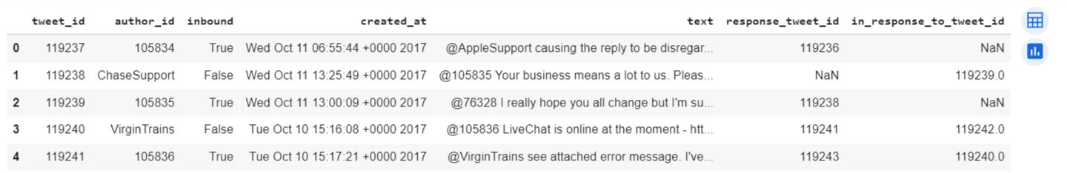

#Lower Casing

df["text_lower"] = df["text"].str.lower()

df.head()

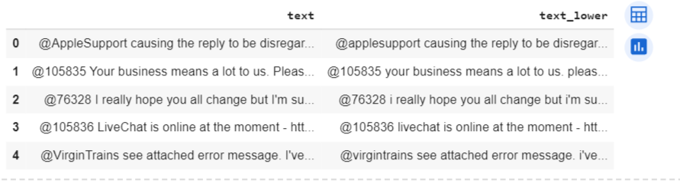

#Removal of Punctuations

#drop the new column created in last cell

df.drop(["text_lower"], axis=1, inplace=True)

PUNCT_TO_REMOVE = string.punctuation

def remove_punctuation(text):

"""custom function to remove the punctuation"""

return text.translate(str.maketrans('', '', PUNCT_TO_REMOVE))

df["text_wo_punct"] = df["text"].apply(lambda text: remove_punctuation(text))

df.head()

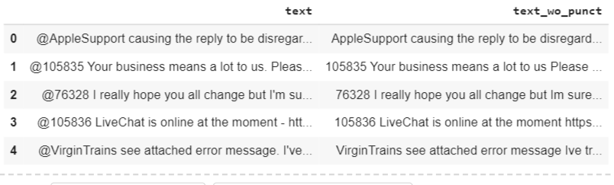

#Removal of stopwords

#Stopwords are commonly occuring words in a language like 'the', 'a' and so on. They can be removed from the text most of the times.

#import nltk

#nltk.download('stopwords')

from nltk.corpus import stopwords

", ".join(stopwords.words('english'))

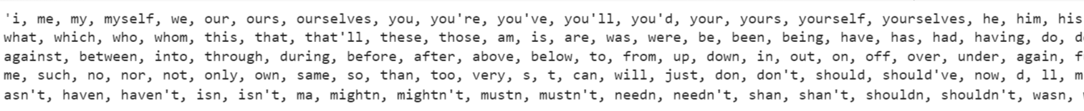

STOPWORDS = set(stopwords.words('english'))

def remove_stopwords(text):

"""custom function to remove the stopwords"""

return " ".join([word for word in str(text).split() if word not in STOPWORDS])

df["text_wo_stop"] = df["text_wo_punct"].apply(lambda text: remove_stopwords(text))

df.head()

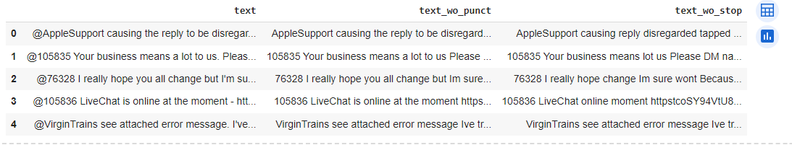

#Removal of Frequent words

from collections import Counter

cnt = Counter()

for text in df["text_wo_stop"].values:

for word in text.split():

cnt[word] += 1

cnt.most_common(10)

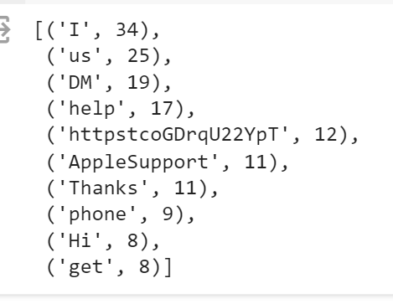

#Removal of Rare words

# Drop the two columns which are no more needed

df.drop(["text_wo_punct", "text_wo_stop"], axis=1, inplace=True)

n_rare_words = 10

RAREWORDS = set([w for (w, wc) in cnt.most_common()[:-n_rare_words-1:-1]])

def remove_rarewords(text):

"""custom function to remove the rare words"""

return " ".join([word for word in str(text).split() if word not in RAREWORDS])

df["text_wo_stopfreqrare"] = df["text_wo_stopfreq"].apply(lambda text: remove_rarewords(text))

df.head()

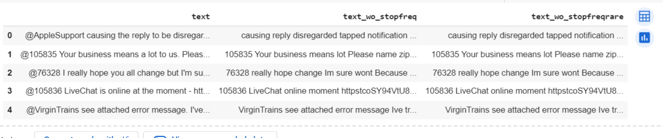

#Stemming

#Stemming is the process of reducing inflected (or sometimes derived) words to their word stem, base or root form

#for example, if there are two words in the corpus walks and walking, then stemming will stem the suffix to make them walk

from nltk.stem.porter import PorterStemmer

# Drop the two columns

df.drop(["text_wo_stopfreq", "text_wo_stopfreqrare"], axis=1, inplace=True)

stemmer = PorterStemmer()

def stem_words(text):

return " ".join([stemmer.stem(word) for word in text.split()])

df["text_stemmed"] = df["text"].apply(lambda text: stem_words(text))

df.head()

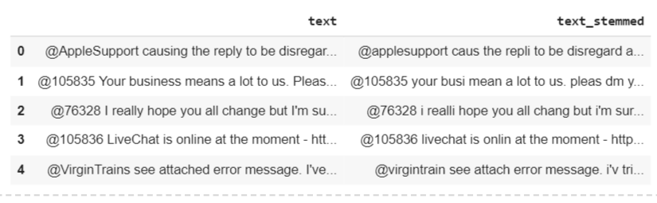

#Removal of Emojis

def remove_emoji(string):

emoji_pattern = re.compile("["

u"\U0001F600-\U0001F64F" # emoticons

u"\U0001F300-\U0001F5FF" # symbols & pictographs

u"\U0001F680-\U0001F6FF" # transport & map symbols

u"\U0001F1E0-\U0001F1FF" # flags (iOS)

u"\U00002702-\U000027B0"

u"\U000024C2-\U0001F251"

"]+", flags=re.UNICODE)

return emoji_pattern.sub(r'', string)

remove_emoji("game is on 🔥🔥")

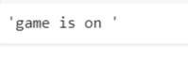

**Experiment 9**

**Aim:** Write a program for Aspect-based sentiment analysis of social media text.

**Flowchart:**

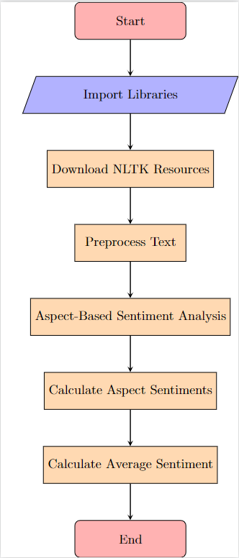

**Code:**

import nltk

from textblob import TextBlob

from nltk.tokenize import word_tokenize, sent_tokenize

from nltk.corpus import stopwords

from collections import defaultdict

# Download necessary NLTK resources

nltk.download('punkt')

nltk.download('stopwords')

def preprocess_text(text):

# Tokenize text into sentences

sentences = sent_tokenize(text)

# Tokenize each sentence into words, remove stopwords and punctuation

stop_words = set(stopwords.words('english'))

preprocessed_sentences = []

for sentence in sentences:

words = word_tokenize(sentence)

words = [word.lower() for word in words if word.isalnum() and word.lower() not in stop_words]

preprocessed_sentences.append(words)

return preprocessed_sentences

def aspect_based_sentiment_analysis(text):

preprocessed_text = preprocess_text(text)

print(preprocessed_text)

aspect_sentiments = defaultdict(list)

for sentence in preprocessed_text:

# Convert list of words back to sentence

sentence = " ".join(sentence)

blob = TextBlob(sentence)

# Extract noun phrases as aspects

noun_phrases = blob.noun_phrases

# Analyze sentiment for each aspect

for aspect in noun_phrases:

aspect_sentiments[aspect].append(blob.sentiment.polarity)

# Calculate average sentiment for each aspect

aspect_average_sentiments = {}

for aspect, sentiments in aspect_sentiments.items():

aspect_average_sentiments[aspect] = sum(sentiments) / len(sentiments)

return aspect_average_sentiments

# Example usage

social_media_text = """

The camera quality of this phone is amazing. But battery life is poor.

I love the design of the new laptop. The performance is also great!

"""

aspect_sentiments = aspect_based_sentiment_analysis(social_media_text)

for aspect, sentiment in aspect_sentiments.items():

print(f"Aspect: {aspect}, Sentiment: {sentiment}")

**Output:**

